Liberation of Garabagh
Ya Qarabağ, ya ölüm

Technical Document
(Homework No.3)

Project team: Gamers
Instructor: Dr. Araz Yusubov

Submitted in partial fulfillment of the requirements of the CSCI 4836: Game Development Fundamentals course project

Version date | Version information
13.11.2018 | Initial draft
18.11.2018 | Final Draft

Team member | Contribution to this homework (NOT the project) | Estimated %
Nezir Yunuszada | 3 | 25 %
Arzu Mammadova | 1,2 | 25 %
Zohrab Musayev | 4 | 25 %
Semed Semedzade | Diagram | 25 %

Table of Contents

Table of Contents 2
1. Introduction 2
System Requirements 2
Concerns and Alternatives 2
Resources 2
2. Visual Content 3
3. Audio Content 3
4. Programming Content 4
Code Structure 5
5. References 6

Introduction
This is part of the Game Design Document for a hypothetical project Liberation of Garabagh, submitted for partial fulfillment of the requirements of the Game Development Fundamentals course in the School of Information Technologies and Engineering at ADA University, Baku, Azerbaijan.

This file consists of all the necessary technical elements of the game including System Requirements, both the visual and audio aspects of the game. As a last part, it includes Programming Content which specifies organized collaboration with the programmer.

System Requirements

The list of the major system requirements includes the below-mentioned points:
- Firstly, the game is going to be available for Windows Operating System; therefore, a device should have Windows OS to run the game.
- Furthermore, the RAM memory will be 512MB for Windows.
- Moreover, the processor requirement will be Intel Core 2 Duo.
- And the last point is about required size for the hard disk which is about 500 MB.

Concerns and Alternatives

Talking about problems, we can mention issues regarding the most considerable aspect to make our product successful - advertising. It is considered expensive, especially when people are on a budget, so we are trying to use other alternative ways like social media, but still we are looking for more efficient paths and methods.

Resources

While developing the game we use the following equipment:
- Unity (as a main developing tool of the game)
- Visual Studio 2017 (as a compiler)

Visual Content
This section lists all the technical requirements from those in concerned with the visual aspects of the game.
- General
  - File Size Restrictions
The game size will be around 500MB if to consider each one of the 50 units of the objects to be 10 MB in size and to consist of prefabs, textures, and images as well.
  - File Format Type
During the game you can observe png, ogg file formats.
  - File Quality Type
Talking about quality, we can say that the screen resolution will be 1024x1024 as a default, highlighting its accordance both with PC and Laptop screens.

  - Visual Scale
As mentioned before, it will be appropriate both for PC and Laptop scales.
- Player Elements
  - An animation Frame here is the tank itself.
  - For our game we will have two types of the states which are Alive and Destroyed. Firstly, while our player is in alive state, Armenian tanks will move toward the player. The second destroyed state says that when player exterminates them with the fire shot down to 0 percent health, they will not be able to move further.
- Heads Up Display (HUD)
  - In this part, we will have icons for Health, Bullets and Pause, where Health and Bullets stand to see the details about the current state and a Pause button will appear on the screen to make a pause or to go to the Menu bar.
  - In the HUD part we will have states for welcoming page, a pause menu and a playing screen itself which is shown during the game.
  - Font Type of the game elements is Cambria.
- Antagonistic Elements
  - The states that we have for Antagonistic elements are again Alive and Destroyed. If an Armenian tank (which is an antagonistic player in our case) is in alive state, then Azerbaijani tanks can move toward the player. If an Armenian tank is in destroyed state, it will not be able to move further.
  - An animation frame for Armenian tanks are Azerbaijani tanks (and vice versa).
- Global Elements
  - As a background global element we can specify the village along with its houses, mountains, trees and a lake.
  - Font Type of the game elements is Cambria.

Audio Content
In this section, we are going to describe how the audio content is interacted within the gameplay. It includes separate sections and each section has its own specific audio requirements.
- General
  - Considering that we have wide range of audio files for player, enemy, global elements. Considering 8 files in total, 3 of them for 2 MB(ambient music; winning ,background, losing music) the others up to 1 Mb, minimum 8-9 Mb will be required.
  - .Ogg is the most relevant format in terms of sound quality for lower bitrates. And additionally it compresses to smaller size. However we will use also .mp3 format for winning music.
  - File Quality Type for .mp3 format lower than 160 doesn’t sound qualitative. .Ogg is 44.1 khZ. So, generally 44.1-160 kHz/Sec is appropriate for our game.

- Player Elements
  - Type of Sound f/x: As a player element, our tank has basic sounds when it is shooting and moving in order to maintain the realistic motion of the game play. These sound files are in .ogg format.
  - Device Vibration: Our game is designed for Windows OS. Considering that we will not deploy it for using on smartphones, device vibration will not be needed. Instead, when collision happens with global elements and enemy tanks, appropriate sound effects will be used.
- Antagonistic Elements
  - Type of Sound f/x: As the player, antagonistic elements also have the same sound for shooting.
  - Device Vibration: Since vibration is not proper for our game, when it collides with player tank collision sound effects will be added.
- Global Elements
Global elements like mountains, stones do not include specific sounds.
Ambient Music: Background music will be played during the gameplay. It will be in .mp3 format. Besides that, when the player element reach the fortress at the end of the game, winning music will be sounded called “Azərbaycan güclü dövlətdir!”. It will also be utilized in .mp3 format
- Splash Screens
  - Ambient Music: In splash screen, as the background music of our game logo which comprised of tank and Azerbaijani flag there will be used short trim from the music called “Azərbaycan”. Since the audio file is very short we can use .ogg format, however, .mp3 format is the best option to guarantee the quality.
- Menus
  - Type of Sound f/x: In the menu screen, action music will be used appropriately using .ogg format. When the gameplay is paused by the player, since it slides into main menu again, music will be sounded

Programming Content
The main target of this section includes good collaboration of the programming content of the game.
- General
  - Requirements
The requirements which are mentioned below:
Graphics card: The game does not require any powerful GPU because we do not have objects that need complex functions. They just play simple visual role.
Operating System: The game will be available for only Microsoft Windows platform. Playing tank games is not convenient for smart phones.
Memory: The 512MB RAM is enough for playing the game. It does not require so much memory space.
Processor: The game requires Intel Core 2 Duo for Windows platform devices.
Hard Disk: Approximately, the game volume will be around 500MB.
  - File Size Restrictions
The game size will be around 500MB that is considered to be 50 units of objects and each of them should be 10MB in size that consist of prefabs, textures, and images.
  - File Format Type
There are .cs(C# scripts), .png, .mp3, .ogg file formats in the game.
  - Specify Coding Conventions
  - Language/Device Restrictions
The main language of the game is English. Taking into the consideration that our game belongs to Garabagh, from patriotic view, it is preferable to have an option for Azerbaijani language in the game.
  - Screen Type (Small, Medium, Large)
Screen resolution will be as default 1024x1024 and it will be suitable both for PC and Laptop screens. Additionally, user can change the screen resolutions from settings to make comfortable view for himself/herself.
- Player Elements
Reach to the fortress
  - Our player involves specific functions that define game play actions. First of all, the tank should be able to move in a 3D platform through the help of arrow keys and alternatively “W”, “S”, “A”, “D” buttons. Moreover, the player will be able to shoot enemy thank by pressing the “SHIFT”. Additionally, player includes functionality to put the bomb via the “SPACE BAR”. We utilize the “OnCollisionEnter” function to detect that we have already reached the fortress.

- Antagonistic Elements
  - Pathfinding
The only antagonistic elements of our game are the enemy tanks. Enemy tanks have AI elements like pathfinding which know the location of our main character and detect it. Shootings from enemy tanks will affect the health of our player.
- Global Elements
  - Making the game challenging
Global elements of our game include houses, trees, and bridges. All these elements will help to make the game more interesting, more challenging because each of them has the box collider. It will help to protect our tank against enemy shooting and vice versa.
- Splash Screens
Change between scenes.
  - In splash screen, there will be a logo which consists of a tank and an Azerbaijani flag including the loading property. The logo will have specific duration within the “isFinished()” method. “Draw()” method renders the logo in a splash screen. After the duration finishes, it automatically changes to the main menu screen. So, as the main functionality of splash screen, main menu will appear after it faded out.
- Menus
Load new screen
  - Menu section includes the “Start Game”, “Options”, “Tank Shop”, “Exit Game”. As we said, the main menu will appear after the splash menu. In the main menu, by clicking “Tank Shop”, player will chose available tanks from the general list. The tanks will have different properties as speed and power. With the help of the options button, sound, graphics will be adjusted.
  - Type of Options
“Start Game”, “Options”, “Tank Shop”, “Exit Game”.

Code Structure

“OnCollisionEnter()” – This function checks whether our tank has reached the “Shusha” fortress or not.
“PutBombs()” - This function is used for placing the bomb into the area to create obstacles for antagonistic elements.
“UpgradeFuel()” – The function maintains for upgrading the level of fuel indicator.
“Shoot()” - It will be utilized for shooting antagonistic elements.

Bonus: Below you can see a Class Diagram that we draw for our game.

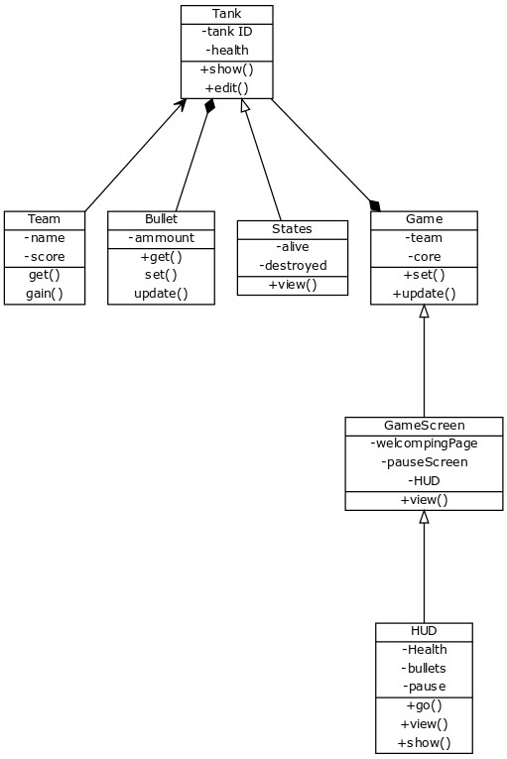

References

- Jeremy Gibson Bond Foreword by Richard Lemarchand, From Concept To Playable Game With Unity and C# (2nd Edition)
- https://yuml.me/diagram/scruffy/class/samples

